

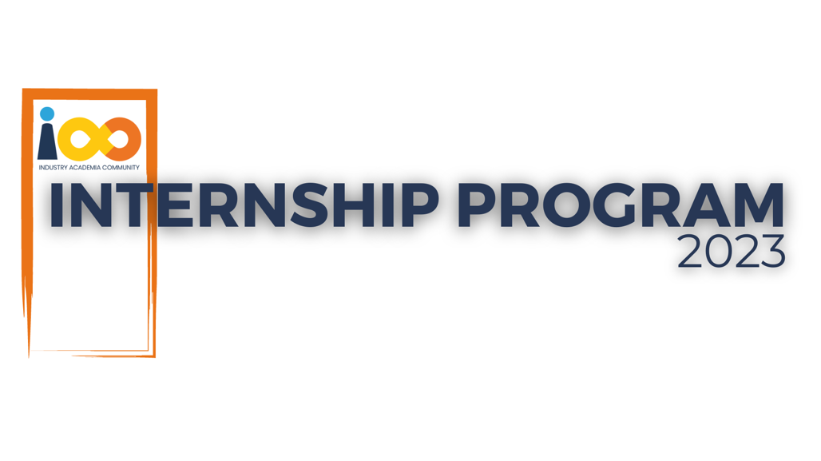

PROJECT REPORT

DATA ANALYTICS  
  
STUDENT RESUME SCREENING

|  |  |  |  |
| --- | --- | --- | --- |
| **Created By:** | Patnam Vivek | **Approved By:** | Patnam |
| **Created On:** | 26-AUG-2024 | **Approved On:** | 16-SEP-2024 |

Page left blank intentionally

# INDEX

1 PROJECT DETAILS 2

2 SUMMARY 2

3 INTRODUCTION 2

3.1 Background 2

3.2 Stakeholders 2

3.3 Objectives 2

4 METHODOLOGY 2

4.1 Considerations & Assumption 3

4.2 Approach 3

4.3 Activities 3

5 TARGETTED V/S ACHIEVED OUTPUT 3

6 CONCLUSION 4

7 APPENDICES 5

7.1 Appendix A – Cost Estimation(Sample) 5

# **PROJECT DETAILS**

|  |  |  |  |
| --- | --- | --- | --- |
| **Project Name** | Student Resume Screening | | |
| **Project Sponsor** | Harshada Topale | | |
| **Project Manager** | Harshada Topale | | |
| **Start Date** | 26-AUG-2024 | **Completion Date** | 16-SEP-2024 |

# **SUMMARY**

To Find Students more efficiently, To find students effectively based on the parameters like experience, family income and more. It can give good idea on students like how many are taken based on some factors. We can successfully analyse the data of students by data analysis.

# **INTRODUCTION**

## Background

To filter students effectively, gather data on academic performance, family background, Python experience, and leadership skills. Create features, select a suitable model, train it, and evaluate performance. Deploy the model for real-time or batch processing. Continuously monitor and update the filter as needed.

## Stakeholders

The platform provides insights for school administrators, fund providers, staff, parents, and students. It collects and analyzes data to inform decision-making, improve student outcomes, and facilitate communication. Key features include data management, analytics, personalized profiles, and communication tools. The platform is designed to be cloud-based, secure, user-friendly, and mobile-compatible.

## Objectives

To analyze student interns, we will examine the relationship between academic performance, event participation, and other factors influencing success. We will use statistical methods to identify key predictors and gain insights for improving the internship program.

# **METHODOLOGY**

**Data Collection:** Gather relevant data on student interns, including academic performance, event participation, and other factors.

**Data Analysis:** Use statistical methods like correlation analysis, regression analysis, and chi-square analysis to identify relationships and trends.

**Interpretation and Insights:** Analyze the results to gain insights into the factors influencing student intern success and develop recommendations for improvement.

## Considerations & Assumption

The student resume screening project faces challenges due to limited data, subjectivity in evaluation, and computational constraints. However, by assuming structured data and keyword relevance, the model aims to accurately assess candidates. It's important to address biases and ensure ethical use of the model.

## Approach

The project aims to screen student resumes for suitable candidates. A structured approach was adopted, involving data acquisition, preprocessing, feature extraction, model selection, training, evaluation, and deployment, fetched key insights using power-BI. Key challenges include limited data, subjectivity in evaluation, and computational constraints. The project assumes structured data and keyword relevance. By addressing these challenges and adhering to ethical guidelines, the model can provide valuable insights for candidate selection.

## Activities

The project involved :-

1. Requirement Gathering and Analysis
2. Project Planning and Scheduling
3. Data Acquisition and Preparation
4. Model Development and Training
5. Deployment and Integration
6. Testing and Quality Assurance
7. Documentation and Knowledge Transfer

Stakeholder interviews and literature review helped define the project scope. Data cleaning and preprocessing prepared the data for modelling. Various machine learning algorithms were evaluated and trained. The model was deployed in a suitable environment and integrated with existing systems. Testing and quality assurance ensured the system's functionality and user satisfaction.

# **TARGETTED V/S ACHIEVED OUTPUT**

**Targeted Output:**

* Develop a robust and accurate student resume screening system capable of identifying suitable candidates based on their qualifications, skills, and experiences.

**Actual Achievement:**

* Developed a functional student resume screening system that can effectively extract relevant information from resumes and categorize candidates based on predefined criteria.

**Reasons for Deviation:**

* Data Limitations
* Complexity of Natural Language Processing
* Subjectivity in Evaluation
* Time Constraints

**Lessons Learned:**

* Data Quality and Quantity
* Model Complexity
* Bias Mitigation
* Iterative Development

# **CONCLUSION**

**Benefits for Stakeholders:**

* **School Administrators:**
  + **Improved student outcomes**
  + **Optimized resource allocation**
* **Students:**
  + **Career guidance**
  + **Goal setting**
* **Faculty and Staff:**
  + **Enhanced teaching practices**
  + **Effective mentorship**

**Future Scope:**

* **Longitudinal Studies**
* **Industry Partnerships**
* **Predictive Analytics**
* **Personalized Learning Paths**
* **Global Perspectives**

# **APPENDICES**

## Appendix A – Cost Estimation (Sample)

|  |  |  |  |  |
| --- | --- | --- | --- | --- |
| Component | Description | Quantity | Unit | Cost |
| Processor | Dell i3 Inspiron 15 3000 | 1 | Unit | $40 |
| Motherboard | Gigabyte B660M DS3H | 1 | Unit | $50 |
| RAM | Crucial DDR4 8GB (1x8GB) | 1 | Kit | $40 |
| Storage | Kingston A2000 256GB NVMe SSD | 1 | Unit | $30 |
| Case | Dell OptiPlex 3060 Small Form Factor | 1 | Unit | $50 |
| Power Supply | 250W | 1 | Unit | $40 |
| Operating System | Windows 11 Home (pre-installed) | 1 | License | $0 |
| Total |  |  |  | $250 |

## 